[2022 지자체와 함께하는 한국유학박람회 개최 안내]

교육부 국립국제교육원에서는 『2022 지자체와 함께하는 한국유학박람회』를 아래와 같이 개최합니다.
1. 행사명: 2022 지자체와 함께하는 한국유학박람회(하반기)
2. 일자: 2022.11.22.(화) ~ 12.1.(목) <10일>
3. 주요메뉴소개
o 한국유학안내, 장학금제도, 대학정보, 온라인 입학신청, 온라인 상담, 채팅상담 등
4. 참가대학: 84개교(9개 지자체-부산, 대구, 인천, 광주, 강원, 충남, 전남, 전북, 경북)
5. 접속 및 참가방법
O 한국유학종합시스템 웹사이트(www.studyinkorea.go.kr)에 접속하여 박람회 링크선택
O 등록(Registration) 후 박람회 기간 중 사이트방문

[Study in Korea Education Fair with Local Governments 2022]
It is our pleasure to announce that NIIED will hold “2022 Study in Korea Online Education Fair(the Second half)” for international students.
- Name of the event: 2022 Study in Korea Online Education Fair(The Second half)
- Date: Nov 22nd (Tue) ~ Dec 1st (Thu)
3. Introduction of main contents
- Studying in Korea, scholarship programs, information about Korean Universities, online application, online consultation, Live Chat
4. Participating universities: 84 universities(The nine participating provincial governments in the 2nd half of 2022 are Busan, Daegu, Incheon, Gwangju, Gangwon, Chungnam, Jeonnam, Gyeongbuk, and Gyeongnam)
5. How to access and join the online education fair (Please see the attachment.)
- Visit the Study in Korea website (www.studyinkorea.go.kr) to select the online education fair link.
- Complete the registration and visit the website during the online education fair.

<Attachment>
How to register“2022 Study in Korea Education Fair with Local Governments”
- Visit the Study in Korea website“www.studyinkorea.go.kr”
- Click “2022 Study in Korea Online Education Fair with Local Governments”
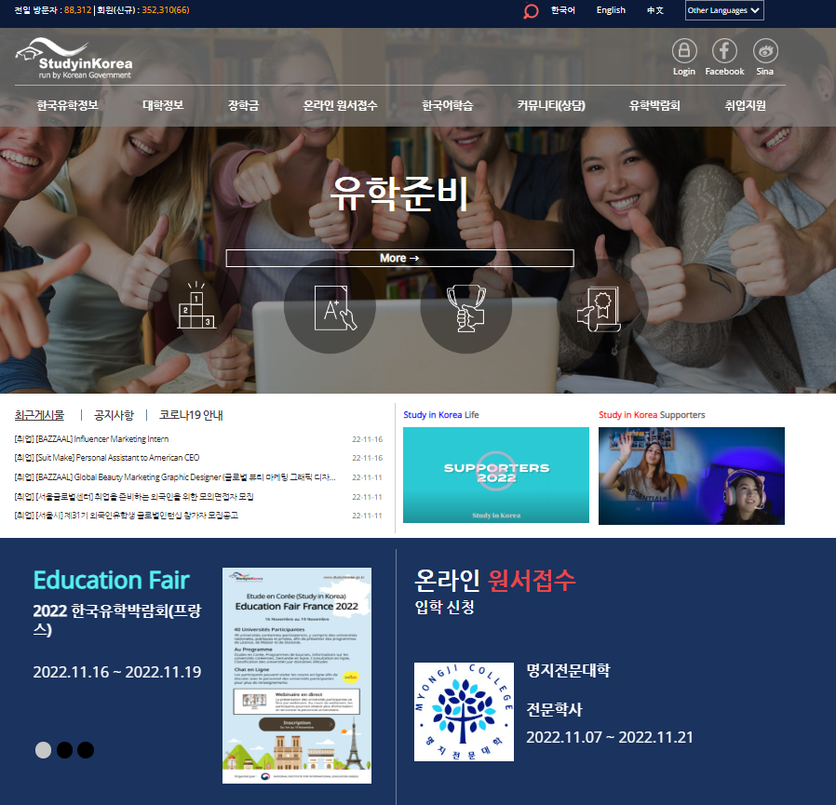

- Click “Registration” to join the Fair.
- Please visit the education fair page during the period of Nov 22nd (Tue) ~ Dec 1st (Thu).

